Gift, Static, Trade Pokémon
 | Pokémon | Level | Location
 | Magikarp | 5 | Route 4- Pokemon Center  (Purchase for 500)
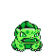 | Bulbasaur | 10 | Cerulean City- Melanie’s House  (Gift, High Friendship with Pikachu)
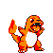 | Charmander | 10 | Route 24- Damien  (Gift)
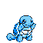 | Squirtle | 10 | Vermillion City- Officer Jenny  (Gift, Defeat Lt. Surge.)
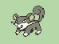 | Rattata | 25 | Vermilion Dock Battle- Under The Middle Truck
 | Magnemite | 30 | SS Anne Bow
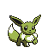 | Eevee | 30 | Viridian City Nickname House  (Gift)
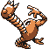 | Hitmonlee | 30 | Saffron City- Fighting Dojo  (Gift, Defeat Dojo Master)
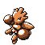 | Hitmonchan | 30 | Saffron City- Fighting Dojo  (Gift, Defeat Dojo Master)
 | Lapras | 30 | Silph Co 7th Floor  (Gift)
 | Omanyte | 35 | Mt Moon Fossil  Revive Cinnabar Lab
 | Kabuto | 35 | Mt Moon Fossil  Revive Cinnabar Lab
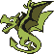 | Aerodactyl | 35 | Petwer Museum Fossil  Revive Cinnabar Lab
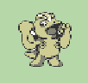 | Machop | 30 | Lavendar Name Rater House
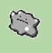 | Ditto | 30 | Celadon Mansion Roof House
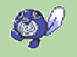 | Poliwag | 30 | Route 12 Super Rod House
 | Meowth | 30 | Celadon Diner
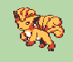 | Vulpix | 30 | Fuchsia Mart
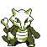 | Marowak  (Ghost) | 35 | Pokémon Tower  (Must obtain Silph Scope)  Cannot Be Caught…
 | Snorlax | 30 | Route 12 & Route 16  (Must obtain and use Poke Flute)
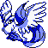 | Articuno | 100 | Cerulean Cave
 | Voltorb | 53 | Power Plant
 | Electrode | 55 to  65 | Power Plant
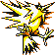 | Zapdos | 100 | Cerulean Cave
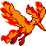 | Moltres | 100 | Cerulean Cave
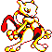 | Mewtwo | 100 | Cerulean Cave
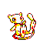 | Mew | 100 | Cerulean Cave
 | Clefairy | Trade Lv | Route 2  (Requires Golbat)
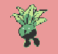 | Oddish | Trade Lv | Vermilion HM House  (Requires Nidoran_M)
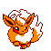 | Flareon | Trade Lv | Route 11  (Requires Farfetchd)
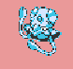 | Tentacool | Trade Lv | Vermilion HM House  (Requires Butterfree)
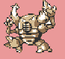 | Pinsir | Trade Lv | Route 18  (Requires Chansey)
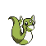 | Dratini | Trade Lv | Cinnabar Island Lab  (Requires Staryu)
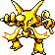 | Alakazam | Trade Lv | Cinnabar Island Lab  (Requires Kadabra)
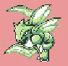 | Scyther | Trade Lv | Cinnabar Island Lab  (Requires Raichu)
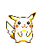 | Pikachu | Trade Lv | Route 16 Gate 2F  (Requires Beedrill)  (Only other Pikachu in game… This one can evolve normal)
 | Horsea | Trade Lv | Cerulean City Melanie’s House  (Requires Spearow)
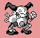 | Mr. Mime | Trade Lv | Viridian Nickname House  (Requires Onix)
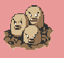 | Dugtrio | Trade Lv | Celadon Hotel Rom  (Requires Lickitung)
 | Goldeen | Trade Lv | Route 5  (Requires Beedrill)
 | Trade With Self | Trade Lv | Super Rod House
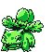 | Ivysaur | 35 | 950 Coins
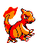 | Charmeleon | 35 | 950 Coins
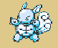 | Wartortle | 35 | 1050 Coins
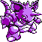 | Nidoking | 40 | 4600 Coins
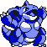 | Nidoqueen | 40 | 4600 Coins
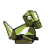 | Porygon | 40 | 1000 Coins
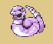 | Ekans | 35 | 1100 Coins
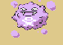 | Koffing | 35 | 1100 Coins
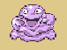 | Grimer | 35 | 1200 Coins
 | Mankey | 35 | 1100 Coins
 | Bellsprout | 35 | 1100 Coins
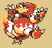 | Magmar | 35 | 1200 Coins

